Portfolio 9

Due 22nd of April 2020

Anders Wheelman, Gustav Helmet, Morten Street and Sigrid Snapfield

### Task 1

#### 1.a. Order of conditions

#### Open one of the paradigm files in Matlab. The variable “names” indicates the order of conditions in the design specification. Report the order of conditions.

The order of the conditions is as follows: blue_neutral, blue_fear, yellow_neutral_ yellow_fear and incorrect. For example, when opening either “durations” or “onsets” for the paradigm file for participant 29, we find that there are twice the amount of onsets and durations for yellow stimuli. Thus, participant 29 is in the yellow frequency group.

#### 1.b. Comprehension question

#### What will the seven contrasts provided in the contrast specification test for? Add a bit of prose to the hypotheses that each contrast could test.

The first contrast (contrast 1, all_pos) tests H1, which hypothesizes that an activation in the occipital face area (OFA) and in the fusiform face area (FFA) would be found across all stimuli.

Contrast 2 (blue vs. yellow) and contrast 5 (yellow vs. blue) test H3, the hypothesis that blue trials will lead to a smaller BOLD response in the motor cortex than yellow trials, because blue trials were executed with the index finger, while yellow trials were executed with the middle finger of the participant. If adding a column in the design matrix indicating frequency group, the two contrasts could also test H4, the hypothesis that infrequent stimuli will yield stronger BOLD response than frequent stimuli (according to which frequency group the participant were in, blue or yellow).

Contrast 3 (fearful > neutral) and contrast 7 (fearful < neutral) test H2, which hypothesizes that fearful images will yield a stronger response than neutral images in mainly emotional regions, e.g. the amygdala.

Contrast 4 and contrast 6 test if there is a difference between the different groups and valence of the stimuli. E.g. contrast 4 tests if there is a difference between the effect of valence in the blue and the yellow group, respectively. Thus, the two contrasts test if there is an interaction effect between the different forms of stimuli compared to the group in which they are in. I.e. we are looking for a differences in differences. If significant, we cannot (strictly speaking) disentangle color and emotion, since we can’t interpret one without the other.

It might help to look at the contrasts differently:

Contrast 4: [-1,1,1,-1] -> [- blue_neutral + blue_fear + yellow_neutral - yellow_fear] <=>

(blue_fear-blue_neurtal)-(yellow_fear-yellow_neutral) <=>

(yellow_neutral-yellow_fear)-(blue_neutral-blue_fear)

Contrast 6: [1,-1,-1,1] -> [ blue_neutral - blue_fear - yellow_neutral + yellow_fear] <=>

(blue_neu - blue_fear)-(yellow_neutral-yellow_fear) <=>

(yellow_fear-yellow_neutral)-(blue_fear-blue_neu)

#### 1.c. Run the preprocessing and participant analyses using the loop

#### The script monitors the time taken to analyse all participants. You can shorten the processing time by dividing participants up into groups and running each on a different computer. You will then need to change the “parnums” variable in the loop script to only run a subset of participants. Report the collected time it took to analyse all participants.

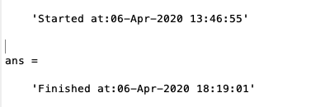

It took about 4 hours for one computer to run the analysis on all the participants.

#### 1.d Include screenshots of these images in your report with a short written evaluation of any concerns related to data from particular participants.

#### During scanning of one participant, the scan seems not to have covered the whole brain. Which participant is this? Only brain areas present in all participants can be analysed. What are the pros and cons of keeping this participant in the dataset, given the hypotheses? What would you choose?

I seems like the scan of participant 5 did not cover his/her whole brain; a large proportion of the ventral brain and a smaller part of the dorsal brain was cut off in the scan.

Participant 25 seems to have a bump on the most superior part of the parietal lobe.

Furthermore, participant 20 and participant 24 seem to have ‘holes’ in their frontal lobes.

By keeping the brain image we have more data to analyse, which is always nice when doing inferential statistics. However, as our hypotheses involve the FFA we need to discard the data in order to actually perform the relevant analysis.

Normalized, unsmoothed wf.images from participant 2-14 including a canonical image at the end:

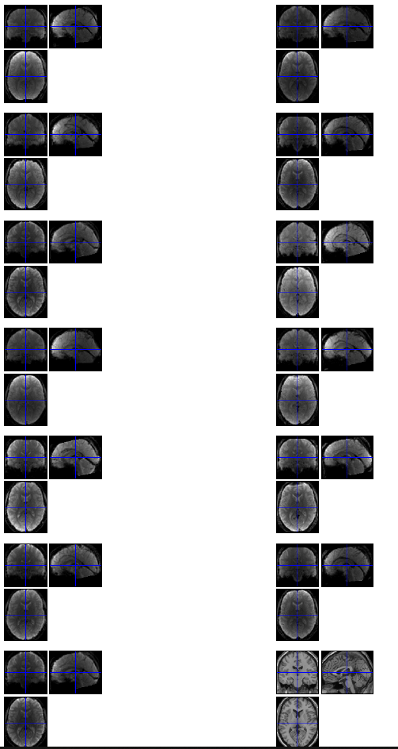

Images 18-29 + canonical image

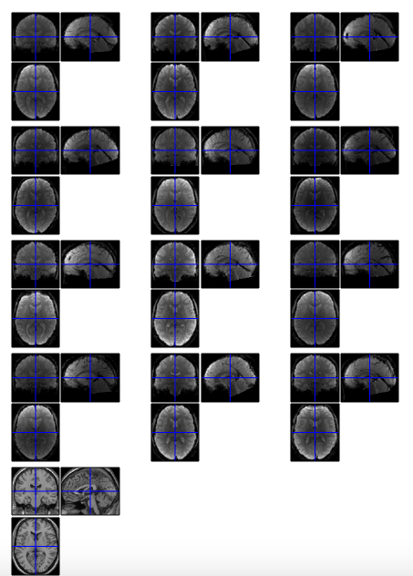

#### Participant 5

#### 

### 2. Investigating analysis of a single participant

#### 2.a. Investigate the design matrix

#### Investigate the design matrix of a single participant using the “Review” function in SPM12 (select a SPM.mat file from a participant). Put a figure of the design matrix in the report. In this particular participant, which stimulus colour was the more frequent, judging from the design matrix? How many, if any incorrect responses did the participant have? Why is it usually a good idea to discard or separately model incorrect responses?

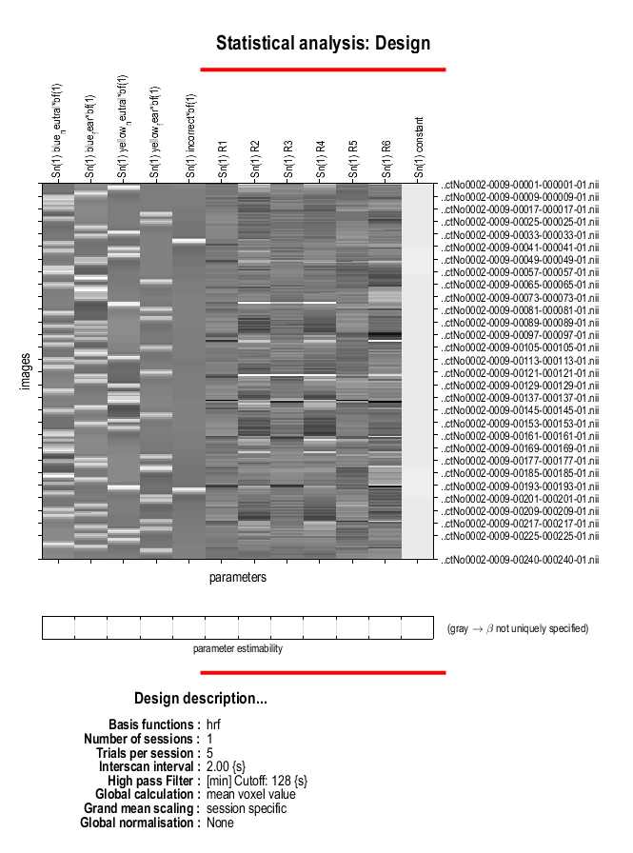

This is the design matrix for participant 002. White bars indicate an on/1; black bars indicate an off/0. It seems like the blue faces (both neutral and fearful) was more frequent, so participant 002 must have been in the blue frequency group. There are two white bars in the “incorrect”-column, so the participant had made two errors.

It is a good idea to discard the incorrect responses because the reaction times of incorrect responses are difficult to compare to the reaction times of correct responses. When looking at brain images, it is also a good idea to discard or model the incorrect responses separately because they are not really useful when modelling the data with the correct responses.

Only including the correct responses can work as a sort of quality check:

When a participant has a correct trial, we can assume that the participant has processed the stimuli in a meaningful and non-shallow way. However, on incorrect trials, the participant might have processed the face in a shallow way. Thus, including the incorrect trials might muddle H1, because faces were only processed shallowly. I.e. we do not know whether our results are due to the experimental manipulation or due to chance.

#### 2.b. Investigate the results

#### Investigate the results of the different contrasts. Choose one participant and report results at p<0.001 uncorrected for multiple comparisons with a nice overlay. Briefly explain if you find signs to support the hypotheses.

We will report the contrasts for participant 002.

**Contrast 1: all positive**

We have included two different overlays of this contrast.

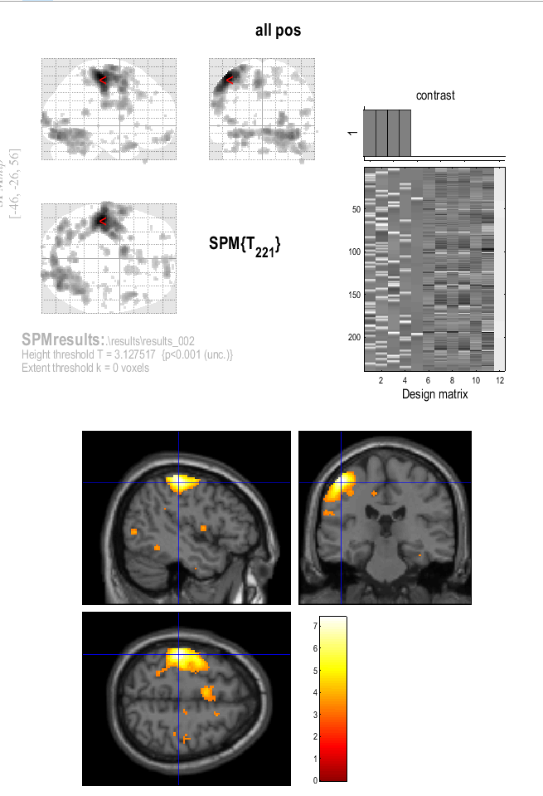

At the image above, the overlay shows great activation in the motor cortex of the participant. This makes sense, since the experiment requires the participant to move his or her fingers in all stimuli. Thus, these results make up a premise for investigating H3.

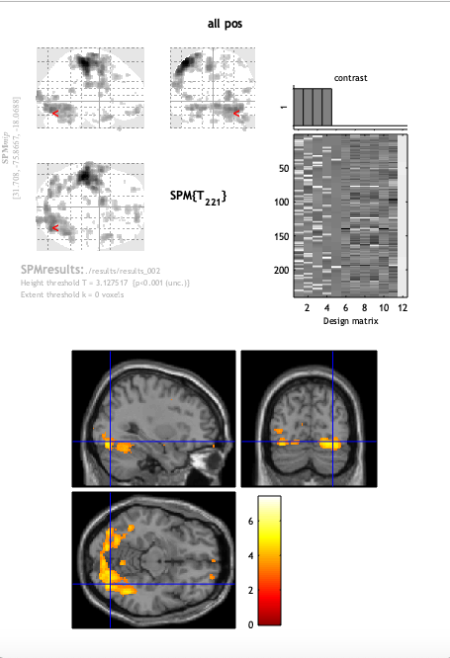

When looking at another overlay for the all_pos contrast (the image above), we can see activation that would support H1. There is great activation in the occipital and temporal lobe lobe, especially in the OFA and FFA among other areas. Furthermore by eyeballing the pictures, there seems to be greater activation in the right temporal lobe, where FFA is located. Thus, the data of participant 002 support H1.

**Contrast 2: blue_vs_yellow**

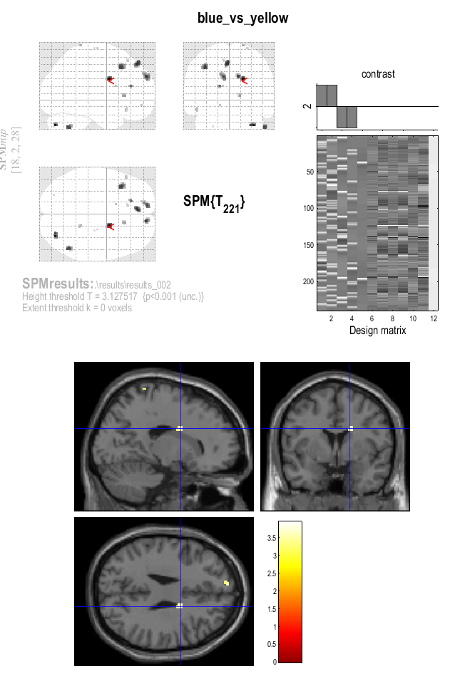

This contrast depicts the significant activation of yellow stimuli compared to blue stimuli.

The overlay shows a small area of significant activation in a subcortical area that does not seem to support H3, since there is no significant activation in the motor cortex.

**Contrast 3: fearful > neutral**

#### 

The overlay shows activation the occipital lobe, possibly around OFA, but not in the FFA or the amygdalae as hypothesized in H2.

However, there is greater response in the fearful stimuli compared to the neutral stimuli, which supports H2.

**Contrast 4: Interaction**

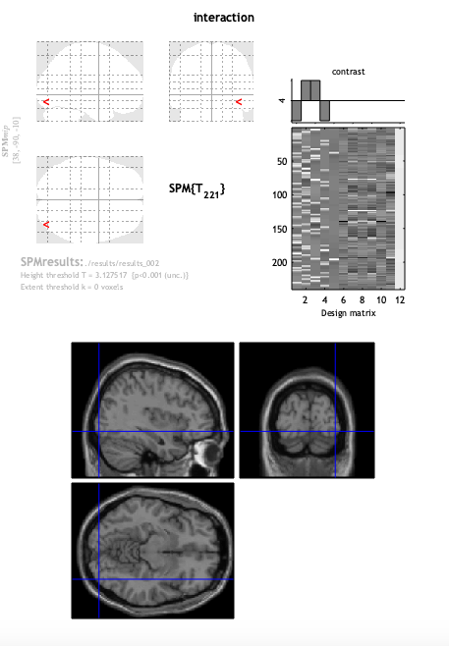

Contrast 4 showed no significant areas.

The difference (blue_fear-blue_neurtal) is not significantly bigger than (yellow_fear-yellow_neutral). It also holds that the difference (yellow_neutral-yellow_fear) is not significantly bigger than the difference (blue_neutral-blue_fear).

**Contrast 5: yellow vs blue**

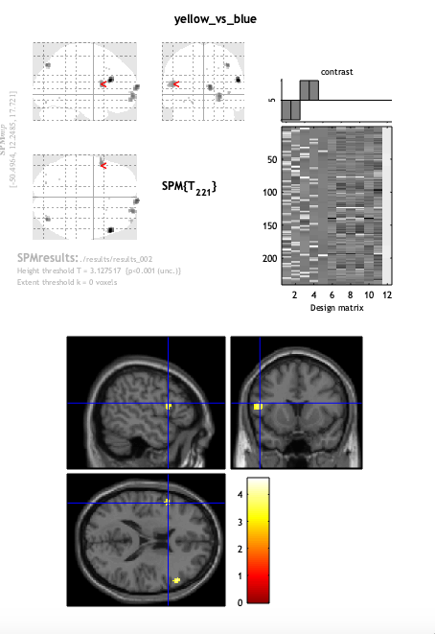

This contrast depicts the significant activation of blue stimuli compared to yellow stimuli.

It is seen, that there is significant activation in some cortical area in the frontal cortex. However, these do not support H3, because there is no significant activation in the motor cortex.

**Contrast 6: interaction2**

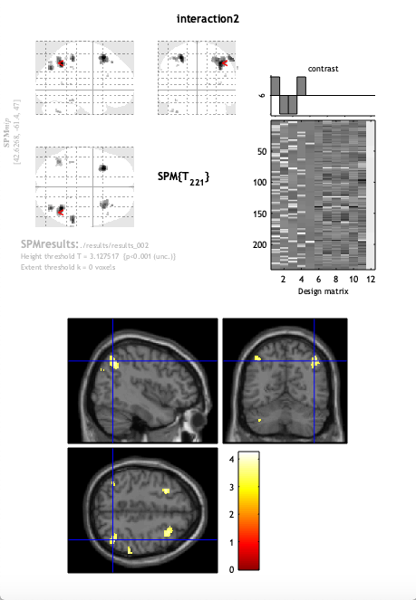

Contrast 6 shows a significant effect of interaction. The contrast elicits activation in posterior parietal lobe bilaterally and frontal lobes bilaterally. There is also a small activation in the cerebellum. Thus, there is a greater difference of valence in either the blue or the yellow trials. But we can’t interpret the “direction”, i.e. whether or not there is greater difference in valence in the blue or in the yellow trials.

This is as far as we got with our interpretation. From this, we cannot conclude the “direction”.

(blue_neu - blue_fear)-(yellow_neutral-yellow_fear)

Blue_neutral is significantly bigger than blue_fear compared to the difference between yellow_neutral and yellow_fear.

(yellow_fear-yellow_neutral)-(blue_fear-blue_neu)

Yellow_fear is significantly bigger than yellow_neutral compared to the difference between blue_fear and blue_neutral.

#### **Contrast 7: fearful<neutral**

#### 

#### This contrast looks at the interaction between the neutral stimuli and the fearful stimuli. There seems to be no significant activation of any brain areas.This supports H2, because there is no significant activation of neutral stimuli, that is not shared with the activation of fearful stimuli.

### 3. Group analysis

#### 3.a. All positive condition

#### Take the contrast images for the “all positive” contrast. Use them to conduct a one-sample t-test, testing if any regions were consistently activated when seeing a face in general.

#### Which contrast would you use on this analysis in order to find positive effects? Report data (image and coordinates) at P<0.05 FWE-corrected for multiple comparisons.

#### If significant, include a nice overlayed image, displaying the most significant/interesting effects.

#### Write a few sentence, interpreting the findings in relation to the hypotheses.

#### If there are results in areas not related to the hypotheses, can these then be explained by the way the study was designed?

We used the all_positive contrast to find effects of faces across participants no matter the emotional feature of the face. These results seem to support H1:There is activation in the occipital lobe and the temporal lobe, which could seem to include OFA and FFA. The activation is greater in the right hemisphere, which further supports H1, because the FFA usually is the most prominent in the right hemisphere.   
Coordinates: (28, -72, -18)

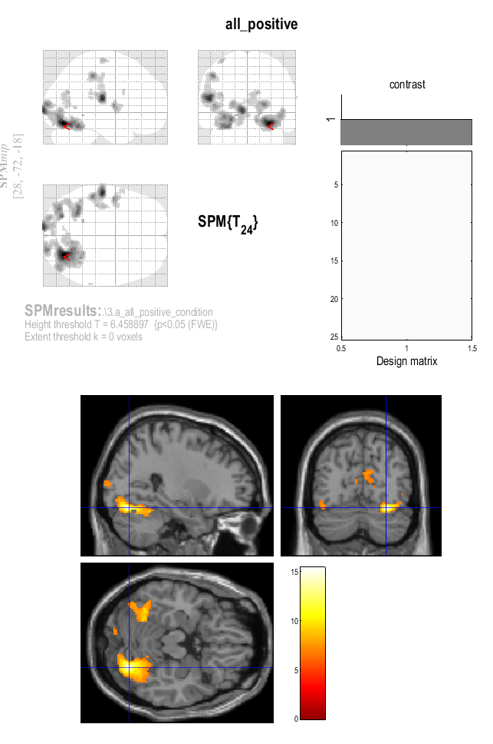

#### 3.b. Effect of emotion

#### Take the contrast images for each participant for the Fearful-Neutral condition. Use them to conduct a one-sample t-test, testing if any region (OFA and FFA in particular) consistently has more activation for the fearful than the neutral faces across participants.

#### Report data (image and coordinates) at P<0.001 uncorrected or P<0.05 FWE-corrected.

#### If significant, include a nice overlayed image, displaying the most significant/interesting effects. Write a few sentence, interpreting the findings.

#### 

We have used contrast 3: fearful > neutral to conduct a one-sample t-test.

The data was uncorrected at p<.001.

Results:

Coordinates: (18, -91,6485, -12,8225)

The results seem to support H2 in part: there is greater activation in posterior ventral stream of facial recognition, i.e. occipital face area (OFA). However, it cannot be concluded that fearful faces causes greater activation in either fusiform face area (FFA) or in amygdalae.

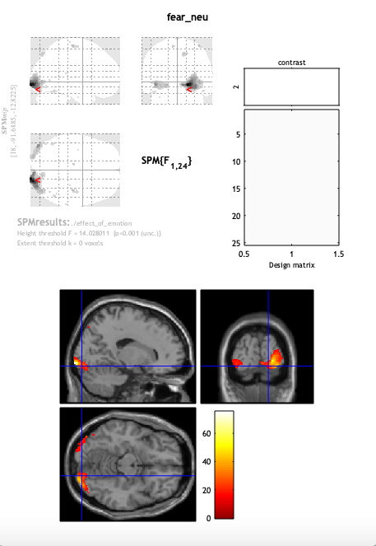

#### 3.c. effect of color

#### Take the contrast images for each participant for the yellow-blue condition. Use them to conduct a one-sample t-test, testing for H3.

#### Report data (image and coordinates) at P<0.001 uncorrected or P<0.05 FWE-corrected.

#### If significant, include a nice overlayed image, displaying the most significant/interesting effects. Write a few sentence, interpreting the findings.

Using contrast 5 (yellow vs blue), a one-sample t-test was conducted using uncorrected data at p<.001.

However, middle finger presses (yellow) do not cause greater activation in the motor cortex than index finger presses (blue), thus, H3 can be discarded.

There seems to be greater activation in V4 in yellow trials, which is unexpected. We wonder why yellow stimuli apparently cause greater activation in V4 than blue stimuli. Both stimuli show color. Maybe we found the brain area for yellow ;)

Coordinates: (-10, -80, 28)

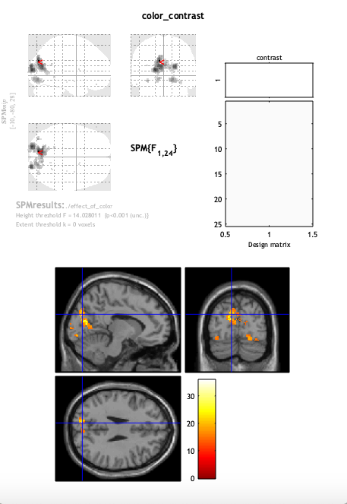

#### 3.d. Frequency group x colour interaction

#### For each participant, find out which colour was the infrequent (e.g. see number of onsets in paradigm files, e.g. using the provided script “face_exp_which_freq_group.m”). If “Blue” was the frequent trial, take the “yellow>blue” contrast (i.e. infrequent-frequent) If “Yellow”" was the frequent trial, take the “blue>yellow” contrast (i.e. again infrequent-frequent) Collect these and conduct a one-sample t-test, testing if any region (OFA, FFA and motor cortex in particular) has more activation for infrequent stimuli compared to frequent

#### (this is equivalent to a mixed-effects 2-way (Frequency group x colour) interaction).

#### Report data (image and coordinates) at P<0.001 uncorrected or P<0.05 FWE-corrected.

#### If significant, include a nice overlayed image, displaying the most significant/interesting effects. Write a few sentence, interpreting the findings.

There are no significant results, neither at P<0.001 uncorrected or at P<0.05 FWE-corrected. This could be due to the fact that the ratio between infrequent and frequent stimuli merely was 1:2, which is not a large difference. If the ratio instead had been for example 1:20, we might expect finding significant results, similar to the mismatch negativity measured in EEG.

### 